Fit Buddy – AI Fitness Plan Generator using Gemini Models

Project name: Fit buddy-AI
Submitted By
Team Leader – [Mariya Darshini] (Roll no: 25ds022)
Team Member –[S. Harini ](Roll no: 25ds016)
Team Member –[R. Subhashri ](Roll no: 25ds041)
Team Member –[S. Mythili ](Roll no:25ds024)

  - Project Overview:
FitBuddy – AI Fitness Plan Generator using Gemini Models is an AI-powered application designed to help users create personalized fitness plans. The system uses Google Gemini Models to generate suitable workout routines and fitness suggestions based on the user’s requirements, fitness goals, and preferences. FitBuddy provides an easy and user-friendly way to plan workouts and maintain a consistent fitness routine. The project demonstrates how Generative AI can be integrated into fitness planning to provide personalized and interactive recommendations.

  - Project Description:
FitBuddy is a web-based application that uses AI to generate personalized workout plans and nutrition tips based on a user’s fitness goals, such as weight loss, muscle gain, or general wellness.
Built with FastAPI and integrated with Google’s Gemini AI models, FitBuddy simplifies the process of creating structured and effective fitness routines.
The application takes in user information—like age, weight, goal, and preferred workout
Intensity—and generates a customized 7-day fitness plan. Users can also submit feedback to update
And refine their plan using AI. A complementary nutrition or recovery tip is also provided based on
Their selected goal.
With a clean user interface and database support via SQLite, FitBuddy ensures each user’s data and
Generated plan are stored and accessible. It offers both API endpoints and an interactive HTML
Interface for ease of use.
  - Scenarios:
Scenario 1 : A user inputs their personal details including name, age, weight, fitness goal (e.g., “weight loss” or “muscle gain”), and preferred workout intensity ( “high”, “medium” or “low”) to Rece
Scenario 2: A user submits feedback on their existing workout plan, such as suggesting changes like “more focus on cardio” or “include more rest days.” The system uses this input to regenerate an Updated workout plan, refining it based on the user’s evolving needs. This feedback loop ensures That users stay engaged and receive dynamic fitness support as their preferences or progress Change.
Their physical training regimen.
Scenario 3: A user requests a nutrition or recovery tip based on their selected fitness goal. The Platform delivers a concise and relevant suggestion (e.g., “Include protein in your post-workout Meal” for muscle gain), which complements the workout plan. These targeted tips help users Improve results by aligning their diet and recovery practices with their physical training regimen.
Scenario 4: An admin or coach accesses the platform to view all registered users and their workout Plans through a dedicated dashboard. This view allows them to track individual progress, compare Original and updated plans, and monitor user activity. It streamlines oversight for trainers managing Multiple clients or students.
Main features:-

- AI-based fitness goal identification.
- Personalized workout recommendations.
- Daily exercise suggestions.
- AI-generated diet and hydration tips.
- Workout difficulty adjustment based on user feedback.
- Progress tracking and workout history.
- BMI and basic fitness calculation.
- SQLite database for storing user and workout data.
- Admin dashboard for managing users and fitness plans.
- FastAPI-based backend with Swagger API documentation.
- Responsive HTML interface using Jinja2 templates..

Technical Architecture:
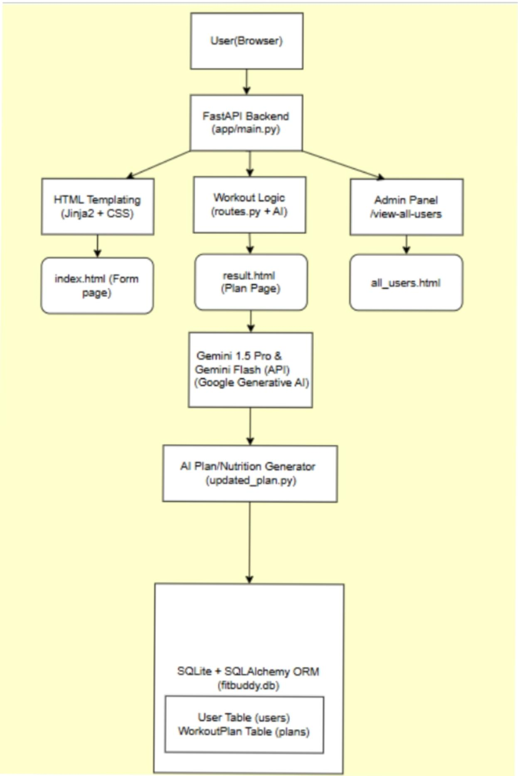

Set Up Project Structure:​
Create folders: /app (Python files), /templates (HTML), /static/images (assets)

Fitbuddy-ai/
│
├── app/
│ ├── __init__.py
│ ├── main.py
│ ├── config.py
│ ├── database.py
│ ├── models.py
│ ├── schemas.py
│ ├── crud.py
│ ├── routes.py
│ └── services/
│ ├── __init__.py
│ ├── gemini_service.py
│ ├── fallback_generator.py
│ └── serializers.py
│
├── templates/
│ ├── base.html
│ ├── index.html
│ ├── result.html
│ ├── all_users.html
│ └── error.html
│
├── static/
│ └── css/
│ └── style.css
│
├── tests/
│ ├── conftest.py
│ └── test_app.py
│
├── data/
├── .env.example
├── .gitignore
├── requirements.txt
├── pyproject.toml
├── start.ps1
├── start.bat
└── README.md

​Workout Plan Generation:
The workout generation module uses Google Gemini 1.5 Pro. The application sends the user’s fitness goal and preferred intensity to the model and requests a structured 7-day workout plan.

• Goal: user’s fitness goal.
• Intensity: user’s preferred workout intensity.
• Each day contains a 5–10 minute warm-up.
• Each day contains a main workout with targeted exercises, sets and repetitions.
• Each day contains a cooldown or recovery tip.
• The generated response is returned as text and stored as the original workout plan.

Nutrition / Recovery Tip
Gemini 1.5 Flash is used for a short nutrition or recovery recommendation. The prompt requests one clear, practical and friendly tip based on the user’s fitness goal.

Feedback-Based Plan Revision

When feedback is submitted, the application retrieves the latest original plan and sends the plan together
With the feedback to Gemini 1.5 Pro. The model revises relevant parts while keeping the remaining format And content unchanged where possible.

Terminal PowerShell:

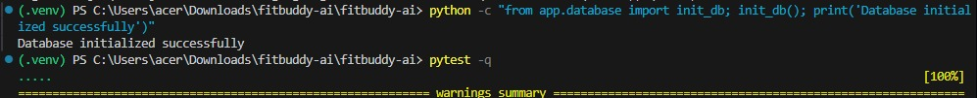
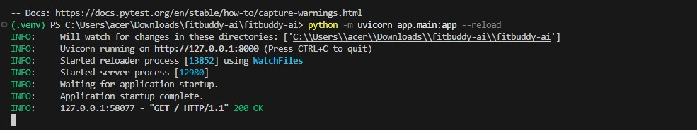
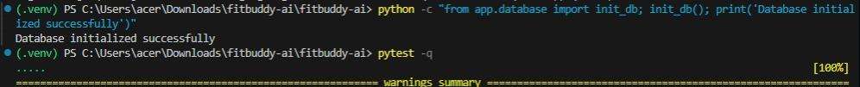

Terminal Description

The image shows the FitBuddy AI – Fitness Planner home page. It provides a simple web interface for users to create a personalized 7-day workout plan using AI.
Header: Contains the FitBuddy AI logo and navigation options such as Generate, Users, and API Docs.
Workout Planner: The user enters their Name, User ID, Age, Weight, Fitness Goal, and Workout Intensity.
Generate Button: The “Generate 7-Day Plan” button submits the user’s information to generate a personalized workout plan.
7-Day Guidance: The interface highlights that the system provides personalized guidance for seven days.
AI Plan: Generates day-by-day warm-up, workout, cooldown, and recovery guidance.
Feedback Loop: Users can provide feedback and regenerate or modify their workout plan.
Persistent Storage: User profiles and generated plans are stored in an SQLite database.
Footer: Indicates that FitBuddy AI provides general wellness guidance and is not medical advice.
Home page:
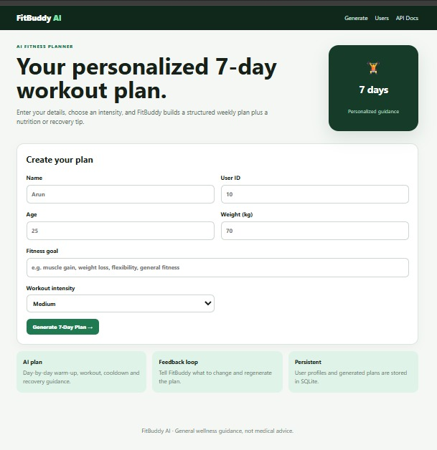

Description:
The FitBuddy AI web interface provides a user-friendly fitness planning system where users can enter their personal details, fitness goals, and workout intensity. Based on the provided information, the system generates a personalized 7-day workout plan along with nutrition or recovery guidance. Users can also provide feedback to modify the generated plan, while user profiles and workout plans are persistently stored in an SQLite database.
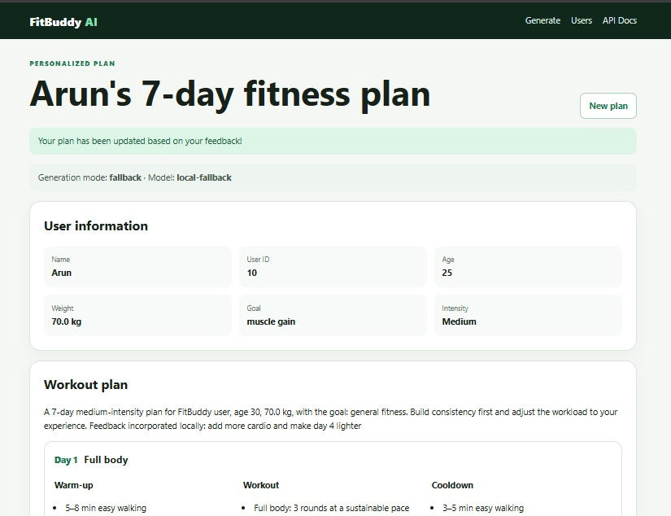
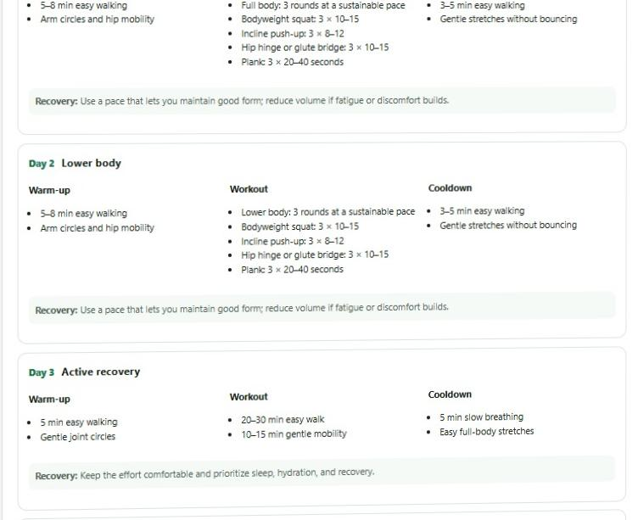
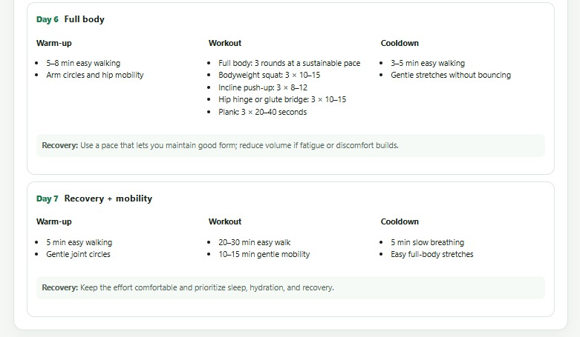

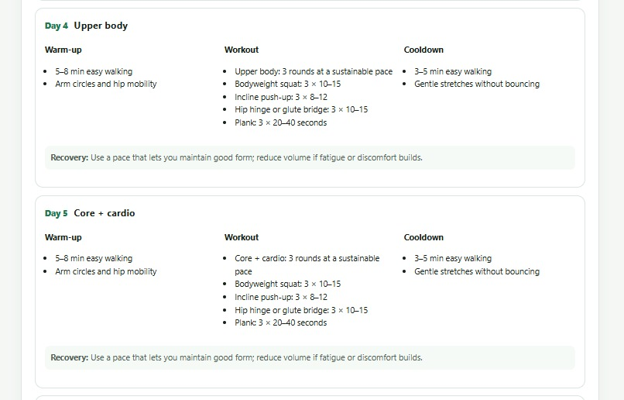

Description:
The FitBuddy AI interface displays a personalized 7-day fitness plan generated for the user based on their fitness information, goal, intensity level, and feedback. The page shows the user details such as name, age, weight, fitness goal, and workout intensity.
The workout plan is divided into seven days, with each day containing warm-up, workout, cooldown, and recovery activities. The plan includes full-body exercises, lower-body workouts, active recovery, upper-body exercises, core and cardio sessions, and mobility activities. The system also allows users to create a new plan and provides access to the Users page and API Documentation.
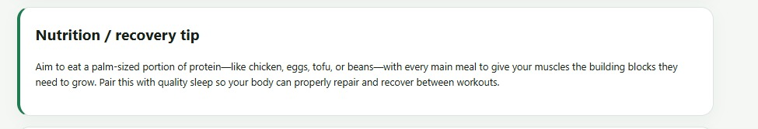
Overall, the interface demonstrates how FitBuddy AI generates and updates a personalized fitness plan according to user requirements and feedback.

Description:
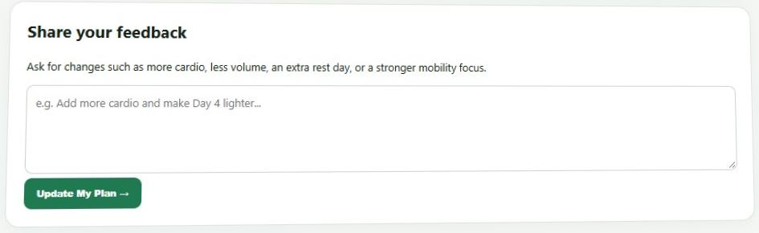
The Nutrition / Recovery Tip section provides personalized guidance to support the user’s fitness goal. It recommends including a protein-rich food such as chicken, eggs, tofu, or beans with main meals to support muscle growth. It also highlights the importance of quality sleep to help the body repair and recover between workouts.This feature provides an AI-generated nutrition and recovery tip along with the personalized fitness plan.

Description:
The Share Your Feedback section allows users to give feedback about their current fitness plan. Users can request changes such as more cardio, reduced workout volume, an extra rest day, or more mobility exercises.
The feedback is entered in the text box, and the “Update My Plan” button submits the feedback. The system then uses the feedback to modify and personalize the workout plan according to the user’s requirements.
Description:
This section displays a success message after the user submits their feedback. The message “Your plan has been updated based on your feedback!” confirms that the system has successfully processed the user’s feedback and updated the personalized fitness plan accordingly.

Conclusion:

FitBuddy demonstrates the use of Generative AI in a web application to provide personalized fitness recommendations. The system integrates FastAPI for backend development, Google Gemini for AI-generated fitness content, SQLAlchemy and SQLite for data storage, Pydantic for data validation, and Jinja2 for the user interface.

The application provides a complete workflow, starting from collecting user fitness information and generating a personalized 7-day workout plan. It also provides nutrition or recovery tips, stores the generated plan in the database, and allows users to give feedback and update the plan based on their requirements.

LINK: https://github.com/Mariyadarshini/fitbuddy-ai

